1. UDP, ARP, and TLSV1.2
2. 

According to the screenshot attached above,

Total time = 710.984267s – 711.008165s

= 0.023898s

1. [gaia.cs.umass.edu](http://gaia.cs.umass.edu/): 128.119.245.12

Home: 10.0.0.7

1. HTTP GET message:

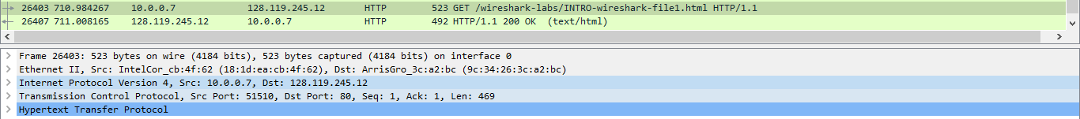

HTTP OK message:

